Computer Language Coding Concepts

No Circular Command Creation in a Diagram
The concept of No Circular Command Creation has already been explained in the article No Circular Command Creation. The current article shows what circular creation could look like

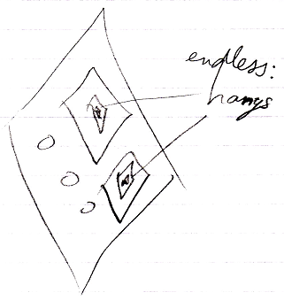

See also: No Circular Command Creation, Commands

Author & Copyright: Jan-Joost van Zon Date: August 31, 2008 – August 31, 2008 Location: Oosterhout, The Netherlands Status: Finished

